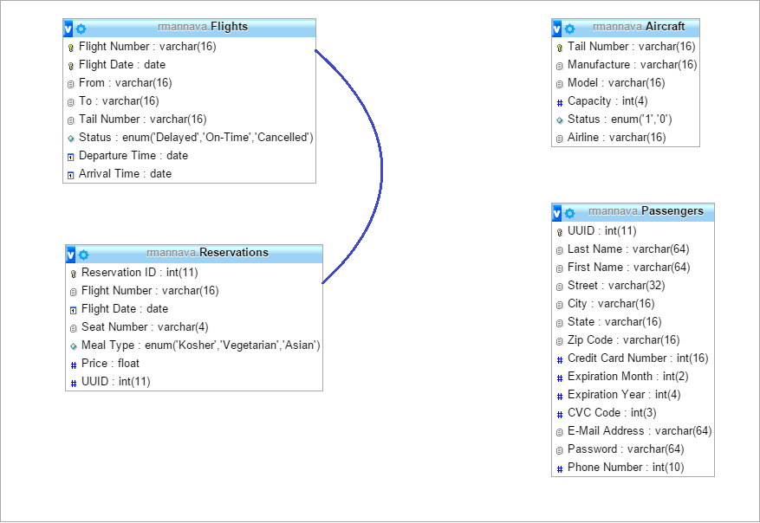

Flight Number & Flight Date

UUID

Tail Number